|  |  |
| --- | --- |
|  | Year 12 Specialist  TEST 3  7 May 2018  TIME: 50 minutes working Classpads **allowed!**  39 Marks 7 Questions |

Name:_______________________________

Teacher: ____________________________

**Note: All part questions worth more than 2 marks require working to obtain full marks.**

Q1 (2 & 2 = 4 marks)

Consider a line with parametric equations 

1. Determine a vector equation
2. Determine a cartesian equation.

Q2 (3 & 2 = 5 marks)

Consider a plane containing the three points A, B & C .

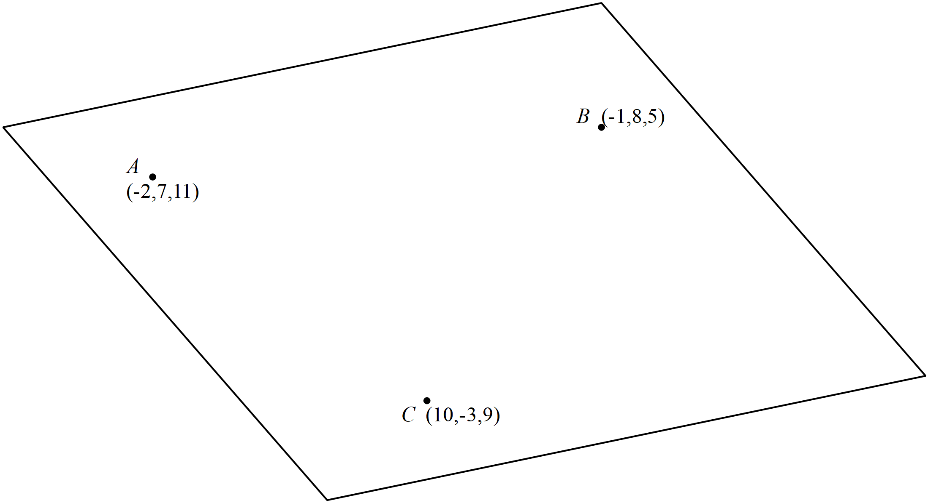

1. Determine the vector equation of the plane.

Continued-

1. Determine the cartesian equation of the plane(simplified) .

Q3 (4 marks)

Determine the distance of point P  from the line 

Q4 (4 marks)

Consider two particles A and B whose position at  is recorded as below moving with constant velocities  . Determine the distance of closest approach and the time that this occurs.

  

 

Q5 (2, 4 & 3 =9 marks)

OABCD is a pyramid. The height of the pyramid is the length of DE, where E is the point on the base OABC such that DE is perpendicular to the base.

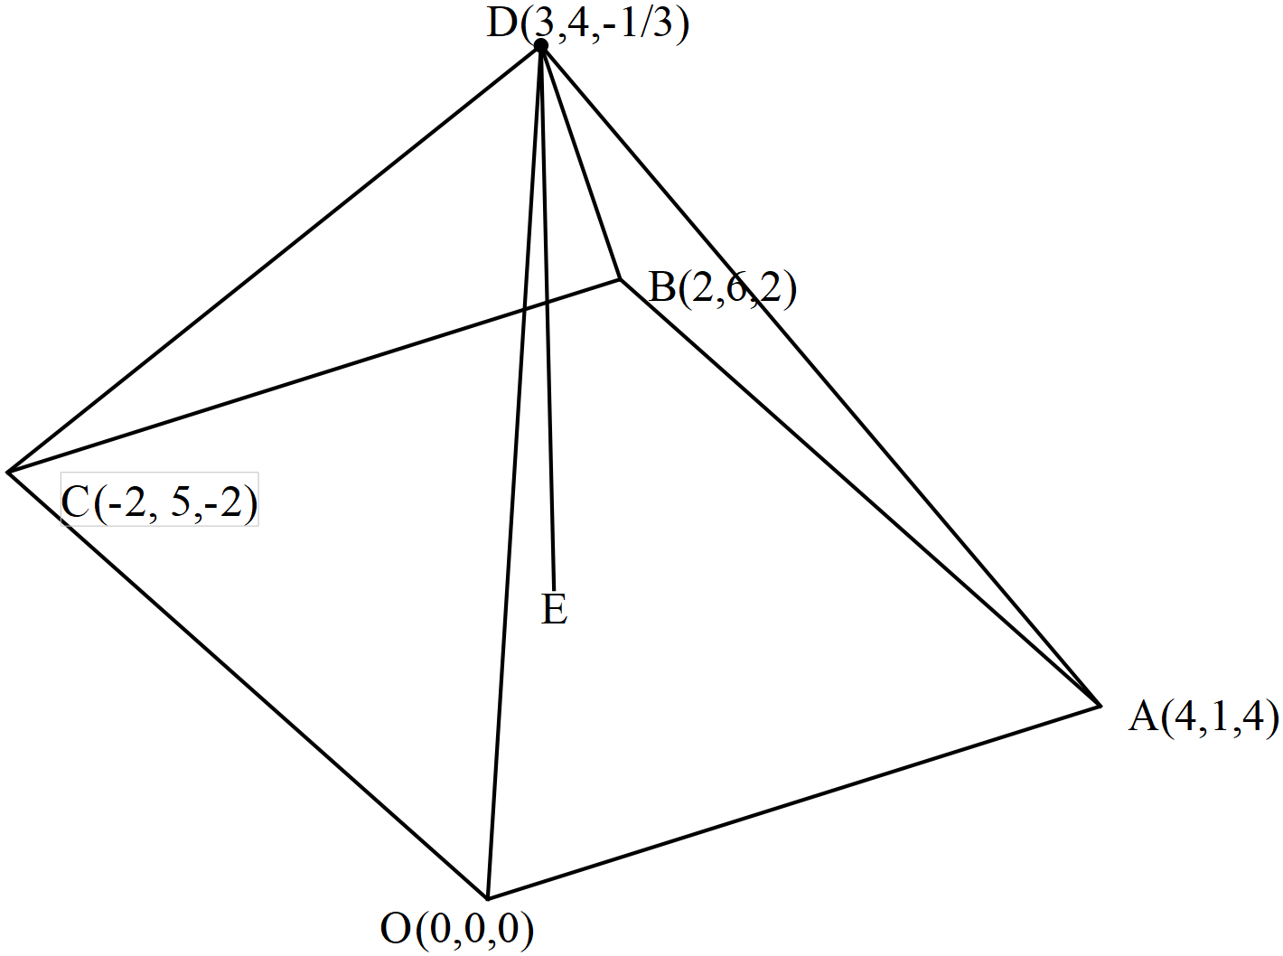

1. Show that the base OABC is a rhombus.

The unit vector  is perpendicular to both  and .

1. Show that  and determine the exact values of .
2. Hence determine the exact height of the pyramid.

Q6 (5 marks)

Consider a sphere of centre and radius of  units , where  is a constant.

The line  is a tangent to the above sphere.

Determine the possible value(s) of 

Q7 (2, 3 & 3 = 8 marks)

Consider the function  where  are constants.

The graph has a stationary point () at  and passes through the point .

1. Write down three linear equations satisfied by .
2. Express  in terms of  **without** the use of a classpad.
3. Determine the value of for which the graph has a stationary point where 

(You may use a classpad here and show reasoning).